**Exercise 1: Ranking and Window Functions**

Query:

CREATE TABLE Products (

ProductID INT PRIMARY KEY,

ProductName VARCHAR(100),

Category VARCHAR(50),

Price DECIMAL(10, 2)

);

-- Sample Data

INSERT INTO Products (ProductID, ProductName, Category, Price) VALUES

(1, 'Laptop', 'Electronics', 1200.00),

(2, 'Smartphone', 'Electronics', 800.00),

(3, 'Tablet', 'Electronics', 600.00),

(4, 'Headphones', 'Accessories', 150.00);

SELECT * FROM (

SELECT

ProductID,

ProductName,

Category,

Price,

ROW_NUMBER() OVER (PARTITION BY Category ORDER BY Price DESC) AS RowNum,

RANK() OVER (PARTITION BY Category ORDER BY Price DESC) AS RankNum,

DENSE_RANK() OVER (PARTITION BY Category ORDER BY Price DESC) AS DenseRankNum

FROM Products

) t

WHERE RowNum<=3 OR RankNum<=3 OR DenseRankNum<=3;

Output :

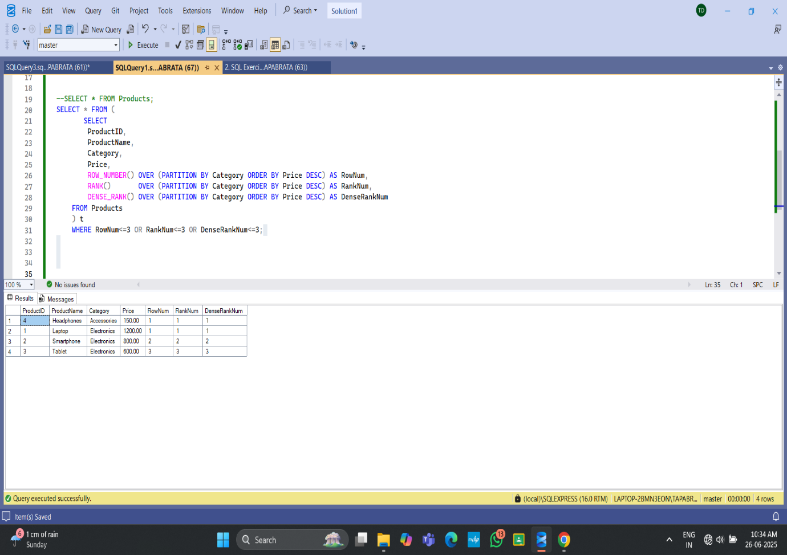

**Exercise 1: Create a Stored Procedure**

CREATE TABLE Departments (

DepartmentID INT PRIMARY KEY,

DepartmentName VARCHAR(100)

);

GO

CREATE TABLE Employees (

EmployeeID INT IDENTITY(1,1) PRIMARY KEY,

FirstName VARCHAR(50),

LastName VARCHAR(50),

DepartmentID INT FOREIGN KEY REFERENCES Departments(DepartmentID),

Salary DECIMAL(10,2),

JoinDate DATE

);

GO

INSERT INTO Departments (DepartmentID, DepartmentName)

VALUES (1,'HR'), (2,'Finance'), (3,'IT'), (4,'Marketing');

GO

INSERT INTO Employees (FirstName, LastName, DepartmentID, Salary, JoinDate)

VALUES

('John','Doe', 1, 5000.00,'2020-01-15'),

('Jane','Smith', 2, 6000.00,'2019-03-22'),

('Michael','Johnson',3,7000.00,'2018-07-30'),

('Emily','Davis', 4, 5500.00,'2021-11-05');

GO

CREATE PROCEDURE dbo.sp_GetEmployeesByDepartment

@DepartmentID INT

AS

BEGIN

SET NOCOUNT ON;

SELECT e.EmployeeID,

e.FirstName,

e.LastName,

e.DepartmentID,

d.DepartmentName,

e.Salary,

e.JoinDate

FROM dbo.Employees e

INNER JOIN dbo.Departments d ON d.DepartmentID = e.DepartmentID

WHERE e.DepartmentID = @DepartmentID;

END;

GO

CREATE PROCEDURE dbo.sp_InsertEmployee

@FirstName VARCHAR(50),

@LastName VARCHAR(50),

@DepartmentID INT,

@Salary DECIMAL(10,2),

@JoinDate DATE

AS

BEGIN

SET NOCOUNT ON;

INSERT INTO dbo.Employees (FirstName, LastName, DepartmentID, Salary, JoinDate)

VALUES (@FirstName, @LastName, @DepartmentID, @Salary, @JoinDate);

SELECT SCOPE_IDENTITY() AS NewEmployeeID,

@FirstName AS FirstName,

@LastName AS LastName,

@DepartmentID AS DepartmentID,

@Salary AS Salary,

@JoinDate AS JoinDate;

END;

GO

EXEC dbo.sp_GetEmployeesByDepartment @DepartmentID = 3;

GO

EXEC dbo.sp_InsertEmployee

@FirstName = 'Olivia',

@LastName = 'Brown',

@DepartmentID = 3,

@Salary = 6200.00,

@JoinDate = '2025-06-26';

GO

Output:

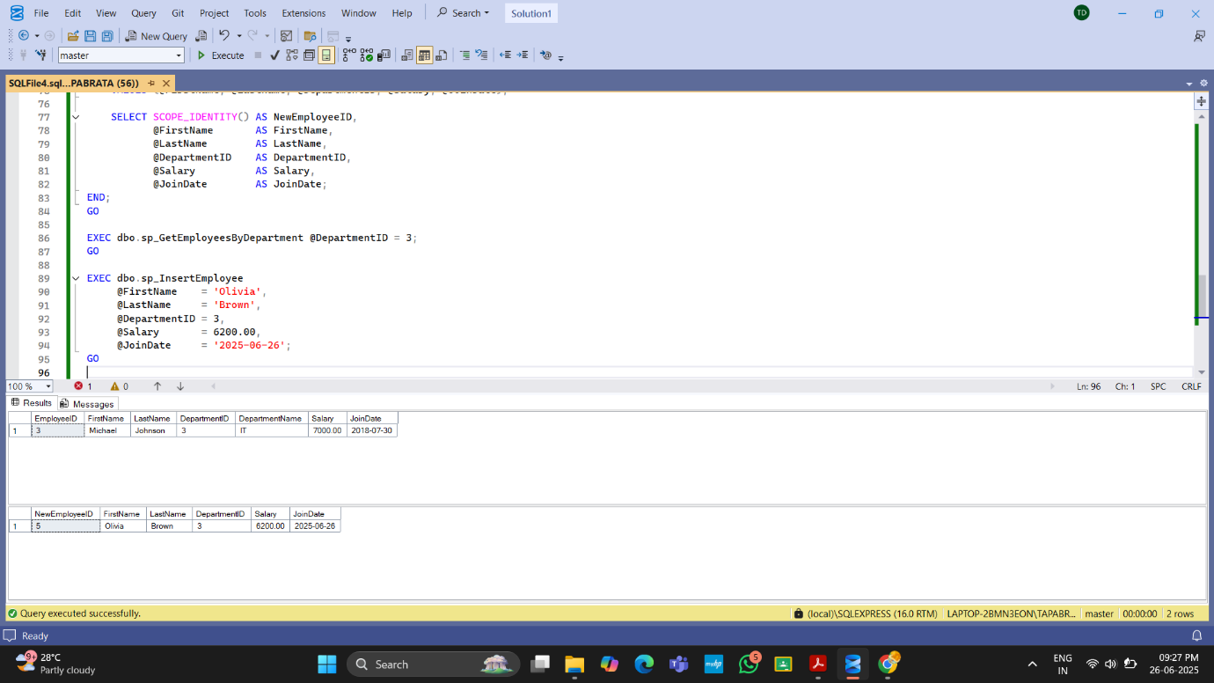

**Exercise 5: Return Data from a Stored Procedure**

Query:

IF OBJECT_ID(N'dbo.sp_GetEmployeeCountByDepartment', N'P') IS NOT NULL

DROP PROCEDURE dbo.sp_GetEmployeeCountByDepartment;

GO

CREATE PROCEDURE dbo.sp_GetEmployeeCountByDepartment

@DepartmentID INT

AS

BEGIN

SET NOCOUNT ON;

SELECT COUNT(*) AS TotalEmployees

FROM dbo.Employees

WHERE DepartmentID = @DepartmentID;

END;

GO

EXEC dbo.sp_GetEmployeeByDepartment @DepartmentID = 3;

Output:

